Case 1: Sales Performance Analysis
Company Background
TechSupply Co. is a regional distributor that sells electronics, office supplies, and office furniture to both retail and business customers. Management wants to better understand sales trends, customer purchasing behavior, and regional performance to improve future sales strategies.
You have been hired as a junior data analyst to explore the sales dataset and provide insights. Your task is to use Excel filtering and sorting tools to answer business questions and provide recommendations.
Dataset: use the techsupply_dataset.xlsx
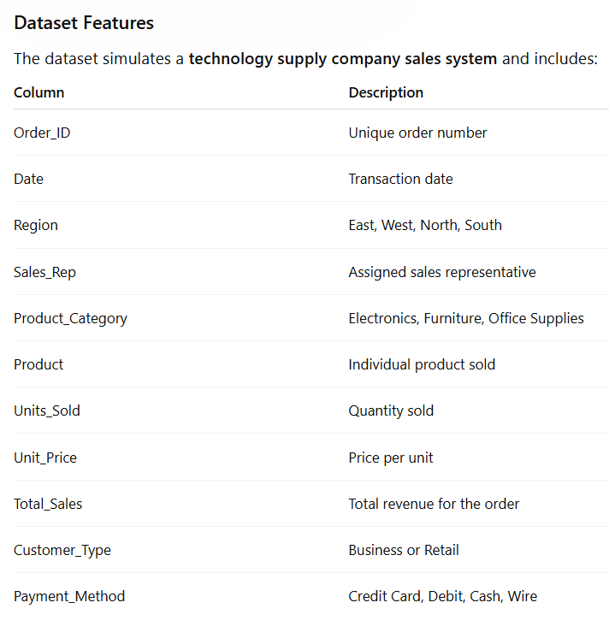

Complete the following 5 tasks.
REGIONAL PERFORMANCE ANALYSIS
Task 1: Use filters to explore sales by region.
- Filter by Region = East
- Sort Total_Sales from Largest to Smallest
Questions:
- What is the largest sale in the East region?
52950
- Which product category appears most frequently?
Desk’s and notebooks both have 11
- Which sales representative appears most often?
Johnson with his name showing up 16 times
CUSTOMER BEHAVIOR ANALYSIS
Task 2: Filter by
- Customer_Type = Business
Questions
- Which product category do business customers purchase most often?
Office supplies coming in at 61
- What is the largest business transaction?
Laptops with 76 Units sold and 63646.2 In sales.
- Which sales rep handles the most business orders?
Its actually a tie between brown and Garcia
PRODUCT PERFORMANCE
Task 3: Use filters to analyze Product_Category.
Analyze each category separately:
- Electronics
- Furniture
- Office Supplies
Questions
- Which category appears to generate the highest total sales?
Laptops do with 75929.88 Sales across business and retail
- Which specific product appears most frequently?
- Which category tends to have the largest individual transactions?
Note books, filing cabinets, and printer paper all appear 27 times each over retail and business.
PAYMENT PATTERN ANALYSIS
Task 4: Filter by Payment_Method
Analyze:
- Credit Card
- Debit
- Cash
- Wire
Questions
- Which payment method is used most frequently?
Wire, at 58 times
- Do business customers prefer a specific payment type?
Yes, business customers prefer Debit. 49 times
- Which payment type is associated with larger purchases?
Wire and cash purchases.
TOP SALES REPRESENTATIVES
Task 5: Sort by:
- Sales_Rep
- Total_Sales(Largset > Smallest)
Questions
- Which sales rep appears to handle high-value transactions?
Garcia
- Which rep appears most frequently in the dataset?
Brown does, 46 Times
- Which region do they appear to sell in most often?
In the east at 81

ANALYST RECOMMENDATION
Imagine you are presenting your findings to management.
Answer the following:
- Which region appears to be the strongest market?
The east region.
- Which product category should the company promote more?
Laptops.
- Are business customers or retail customers more valuable?
Business.
- What two recommendations would you give the sales manager?

Bonus
Build
- Bar Chart – Sales by Product Category
- Pie Chart – Customer Type Distribution
- Column Chart – Sales by Region
Allocate more resources to the east region, and prioritize laptop sales.
What story does the data tell?
Laptops sell the most and retail customers are almost as valuable as business customers.

